Books on the T trying to give Boston a daily dose of literature
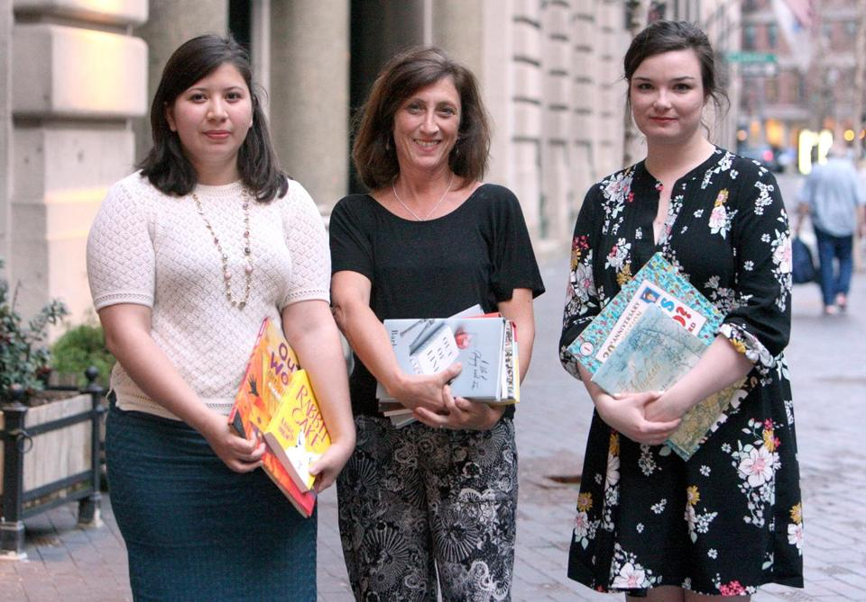
John Blanding/Globe Staff
Books on the T organizers (from left) Araceli Hintermeister, Judy Gelman, and Catherine Gaggioli.

By Melissa Schorr Globe Correspondent April 26, 2017
Could your morning commute use a little fairy dust?
A new program, Books on the T, hopes to sprinkle a daily dose of literature into Bostonians’ lives, relying on volunteer “book fairies” to place multiple free copies around the area’s railways and buses for lucky riders to take, read, and recirculate — essentially turning the transit system into a mobile lending library.
“I think these projects are a celebration of the fact that people still love reading,” says Simmons College library science graduate Catherine Gaggioli, one of the founders. “These community projects are just like recommending a book to a friend, except the friend is an entire city.”
The idea first sprung up in London’s Underground and was the brainchild of Hollie Fraser, an advertising-industry art director who began leaving personal copies of books on the Tube back in 2012 for fellow riders. One enthusiast, fellow ad agency executive Rosy Kehdi, reached out and brought the concept to New York City, founding Books on the Subway a year later.

Together, they have placed several thousand copies into circulation and won the support of book publishers for donations, as their Books on the Move Global initiative has spread to transit systems in Washington D.C., Chicago, Montreal, and Sydney, and been plugged by celebrities such as Emma Watson and Anna Kendrick.
Judy Gelman, a Dover-based author, was inspired to help bring the concept to Boston after a copy of her own book, “The Unofficial Mad Men Cookbook,” popped up on the Twitter feed of Books on the Subway, late last year. The cookbook, whose subject naturally appealed to the two ad agency founders, was photographed held up against a Madison Avenue street sign and then hidden in a station near Madison Square Park.
“It was so fun and creative, says Gelman, who imagined commuters enjoying their reading that evening, “and perhaps mixing a few cocktails.” She teamed up with librarian Araceli Hintermeister of Brookline, who had coincidentally made similar inquiries and in turn recruited Gaggioli, to round out the trio.
MBTA officials took a little convincing, but now they, too, are onboard.
The giveaways, which launch April 27, will span all genres, from picture books to poetry, and will typically include around 5-20 copies of a single title each day, all furnished by participating publishing houses. The book fairies will secrete their daily stash, then promote the treasures with clues left on social media, using the hashtag: #BooksOnTheT.
Each jacket cover will feature a distinctive sticker, to ensure the book is not simply mistaken for another rider’s abandoned read, a lesson learned early on by the founders.
“We’ve both had a lot of people run after us, thinking we’ve left our book behind,” explains Books on the Underground founder Fraser. “I now make a concerted effort to show people that I’m leaving the book there on purpose. . . . The books have a sticker that says ‘Take me, Read me and Return Me,’ so it’s really clear what book finders have to do.”
The impulse to free books from traditional venues and distribute them in the wild, a practice known as bookcrossing, seems to have gained a foothold in the past few years — witness the growing presence of Little Free Library community-book exchanges.
Gaggioli says that she believes social media has given the movement a boost. “Everyone is sharing what they’re reading, watching, and listening to all the time,’’ she says. “Making the sharing physical again is exciting; instead of just reading someone’s tweet about a book they loved, you have the chance to actually encounter it unexpectedly in person.”
Naturally, Books on the T hopes to deliver a Boston flair, drawing on the area’s deep literary bench to spotlight local authors and subject matter, while also making room for premier authors who happen to be in town on a book tour.
First up will be “Out of Wonder,” a picture book celebrating poetry illustrated by Roxbury resident Ekua Holmes (coauthored by Kwame Alexander), followed by South Boston native Barbara Lynch’s new memoir, “Out of Line: A Life of Playing With Fire,” and Dedham native Anita Shreve’s “The Stars Are Fire.”
Much of the fun, the three organizers say, will be in tying a book’s theme to its secret location — for example, picking a station to hide the John F. Kennedy picture book, “Patrick and the President,” this Memorial Day, or David Ortiz’s upcoming May release, “Papi: My Story.”
While publishers large and small have been willing to donate complimentary copies, the goal is less one of marketing, more about promoting literacy, explains Gaggioli. “If the books never somehow make it back into circulation,” she says with a shrug, “we’re OK with that.”
A few weeks before the launch, the trio gathers some 10 fairies-in-training at a downtown restaurant to review their duties. They come from all walks of life — a computer programmer whose mother was a library trustee, a book binder, a recent grad/waitress — lured by this bookish mission with a creative twist.
The volunteers pass around copies of the upcoming freebies (one perfectly-themed pick: Candlewick Press’s 30th anniversary re-release of its classic “Where’s Waldo?”) while Hintermeister and Gaggioli review the process and how to find hiding places.
“We want it to be visible, so that people see it, and take it,” Gaggioli instructs. “A lot of the stations have nooks and crannies,” she says. Benches are another good option.
She also stresses the importance of keeping MBTA officials happy, not placing books where they might obstruct doorways or ramps, incur water damage from the elements (“a lot of T stations leak,” she notes), or above all, take up precious seats during rush hour.
“We want to make the T more fun,” Hintermeister says, “not more annoying.”
Melissa Schorr is a contributing editor at the Boston Globe Sunday Magazine. Her upcoming nonfiction book, “Shame Nation: The Global Epidemic of Online Hate,” will be published by SourceBooks in October.

